**Batch: B2 Roll No.: 1611099**

**Experiment / assignment / tutorial No. 5**

**Grade: AA / AB / BB / BC / CC / CD /DD**

**Signature of the Staff In-charge with date**

|  |
| --- |
| **Batch: B2 Roll No.: 1611099 Experiment / Assignment / Tutorial No.: 5** |

|  |
| --- |
| **Title: Installation & configuration of DNS Server.** |

**Objective:**

1. To install & configure DNS Server.
2. To understand the functioning of a DNS server.

**_____________________________________________________________________________**

**Expected Outcome of Experiment:**

CO3. Manage the configurations by using network administration tools.

**___________________________________________________________________________**

**Books/ Journals/ Websites referred:**

1. Linux Lab - Open source Technology : Ambavade –Dreamtech.
2. https://help.ubuntu.com/lts/serverguide/serverguide.pdf
3. http://www.krizna.com/ubuntu/configure-dns-server-ubuntu-14-04/
4. https://www.verisign.com/en_US/website-presence/online/how-dns-works/index.xhtml

**____________________________________________________________________________**

**Pre Lab/ Prior Concepts:**

Computer networks, web technologies etc.

______________________________________________________________________________

**New Concepts to be learned:**  Installation of bind9, configurations for DNS and impact of the configurations. DNS Server, Packages for DNS.

**Introduction:**

The Domain Name System, or DNS, is one of the Internet's fundamental building blocks. It is the global, hierarchical, and distributed host information database that's responsible for translating names into addresses and vice versa, routing mail to its proper destination, and many other services.

BIND (Berkeley Internet Name Domain) is an implementation of the DNS protocols and provides an openly redistributable reference implementation of the major components of the Domain Name System, including:

1. Domain Name System server

2. Domain Name System resolver library

3. Tools for managing and verifying the proper operation of the DNS server

The BIND DNS Server, named, is used on the vast majority of name serving machines on the Internet, providing a robust and stable architecture on top of which an organization's naming architecture can be built. The resolver library included in the BIND distribution provides the standard APIs for translation between domain names and Internet addresses and is intended to be linked with applications requiring name service.

**Implementation details:**

A). Configuration of Forward Zone

1. db.example.com

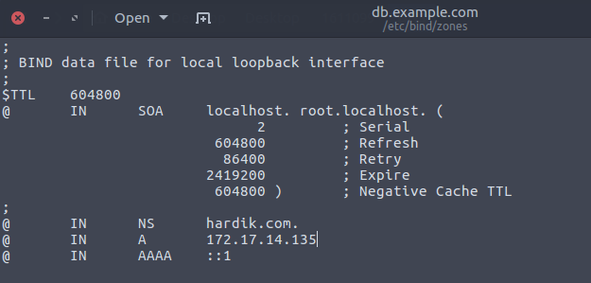

2. named.conf.local

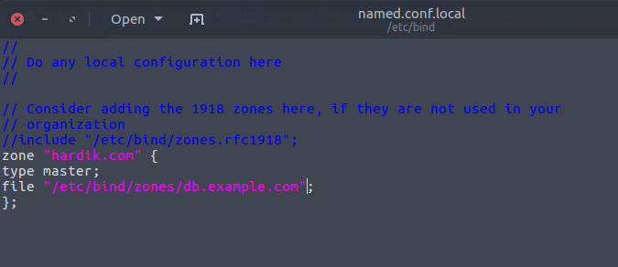

3. resolv.conf

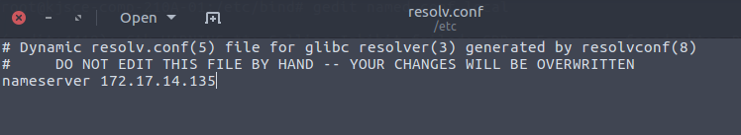

4. named.conf.options

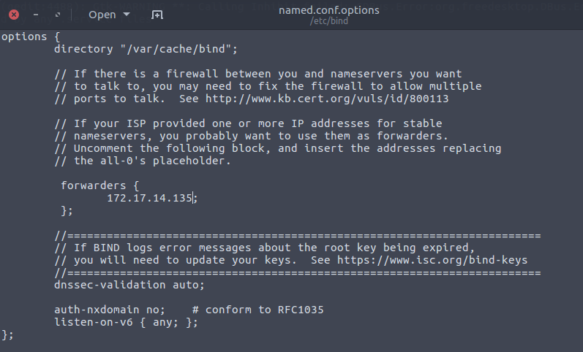

5. Checking forward zone

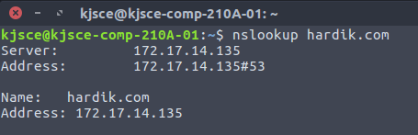

B). Configuration of Reverse zone

1. db.172

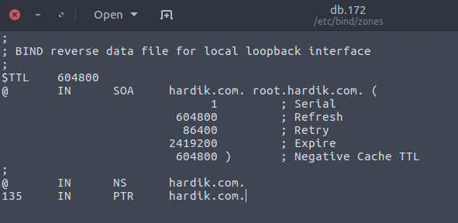

2. named.conf.local

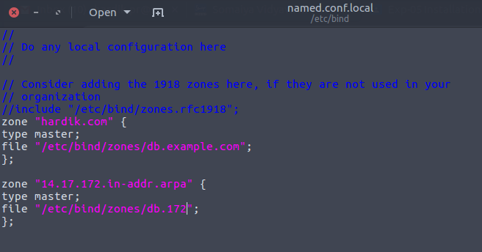

3. Checking Reverse Zone

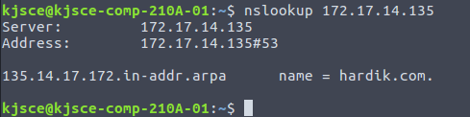

**Conclusion:** Thus, we have understood the working of DNS server and also installed and configured DNS server using bind9 and implemented forward and reverse zone.